Office Guide Hamburg
Am Sandtorkai 41, 20457 Hamburg (HafenCity)
Julia Hoffmann · 09 February 2026
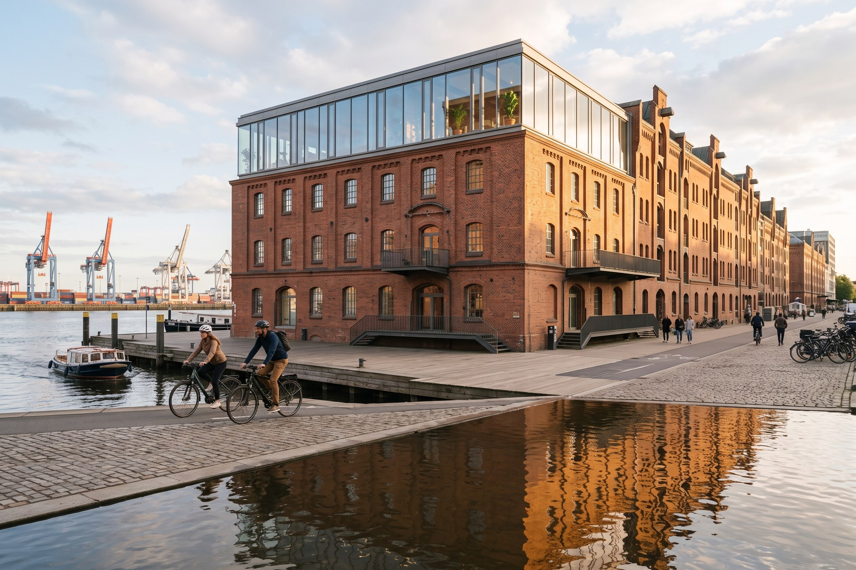
Weyland office Hamburg
Address: Am Sandtorkai 41, 20457 Hamburg (HafenCity)

Getting here
U3 Baumwall or U4 Überseequartier (7 min walk). Bike racks in the courtyard, 6 charging points in the garage (book via reception).

Reception
Ground floor, staffed 08:00–18:00. Visitors sign in at the tablet; badges are returned on leaving.

Floors
1st: Finance, Legal, HR · 2nd: Engineering, HSE, Grid & Permits · 3rd: Projects, Procurement, IT · 4th: Executive Board, boardroom 'Elbe' and the roof terrace.

Meeting rooms
Named after North Sea islands (Sylt, Föhr, Amrum, Helgoland). Book in the calendar; 'Helgoland' seats 20 and has video conferencing.

Food
Kitchen on every floor, free coffee, fruit on Mondays and Thursdays. Canteen 'Kaiserkai Kantine' next door with 20 % discount.

IT
IT Service Desk on the 3rd floor (Sophie Martin), Tue–Thu walk-in 09:00–12:00.

Moved here
September 2024 – before that we were in Altona.
Emergency: 112. Office first aiders are listed at the kitchen on each floor.

